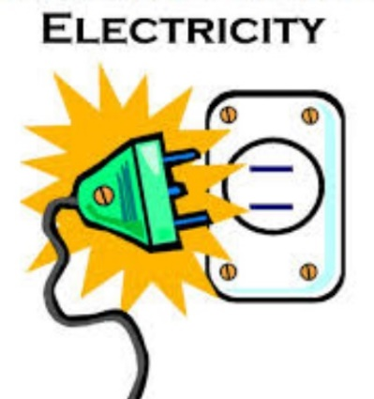

**Literacy**

**Reading**: Pupils will prepare, read and discuss Oxford Reading Tree texts from stages 3-5 at home and in school. Guided Reading books will be read in class. Group 1 will begin Accelerated Reading and books will be available from the library. Pupils will engage in shared reading in class.

**Grammar:** Know how to use capital letters and full stops. Children will also be learning about nouns, using and identifying them in a range of contexts. The children will be encouraged to sequence sentences and stories both orally and written.

**Writing**: Children will write clear descriptions of familiar objects and people. They will rewrite a story with the focus on sequencing. They will create disgusting potions and scary stories for Hallowe’en!

**Handwriting:** The children will revise all letter formation with particular focus on distinguishing between b and d.

They will also work on writing on lines and leaving even spaces between words.

.

**Numeracy**

**Mental Maths**: Count forwards /backwards within 20/50. Have quick recall of number stories up to 10. Understand the link between doubles and halves . Be able to add and subtract within 20 without using a numberline.

**Number:** Read, write and order numbers up to 50. Know how to add 2 digit numbers vertically. Find connections and patterns in numbers on the wonderful hundred square. Begin to develop the habit of self-checking their work.

**Data Handling:** Know how to sort information about houses using a block graph. Be able to interpret information from block graphs and record information about graphs.

**Measures:** Engage in practical estimation and measuring using handspans and feet.

**How To Help Your Child**

* **Be positive and encourage your child by showing an interest in their work.**
* **Expect high standards of homework from your child.**
* **Praise always helps.**
* **Listen to your child reading aloud–talk about the story and sign the homework diary.**
* **Practice mental maths skills with pupils at all opportunities - E.g. counting coins, estimating amounts, adding and subtracting small numbers.**
* **Practice fast recall of number facts through use of counting games.**
* **Help pupils to understand Maths topics through experience of shopping, sharing in equal amounts ,telling the time.**
* **Be supportive of the teacher in conversations with your child.**

**Topics**

All Topics are cross curricular to enable pupils to connect their learning.

**Sept/Oct = “Home Sweet Home”**

**St.Eugene’s P.S. Derry**

**Class Newsletter**

**Sept/Oct 2020 - Year 3** [](http://www.google.co.uk/url?sa=i&rct=j&q=children%20holding%20hands%20clipart&source=images&cd=&cad=rja&docid=wswpzU6d_lxawM&tbnid=OZHOjAE8LYDaoM:&ved=0CAUQjRw&url=http://www.argyllmausoleum.org/index.asp?pageid=352012&ei=SBv5Uf7KGuah0QWoxoGYCQ&bvm=bv.49967636,d.d2k&psig=AFQjCNHX_m6iiRsVzhCbbjEojAx-oqL7ww&ust=1375366323007920)

**Homework**

**Homework** activities will be written in the Homework Diary by the teacher and signed by parent every night. Any concerns can be noted here also.

Reading and spellings every night.

Written Literacy Mon&Wed

Written Numeracy Tues&Thurs

**Spellings:**  Monday to Thursday for assessment on Friday. Spelling test to be signed every weekend.

http://p3cdn4static.sharpschool.com/UserFiles/Servers/Server_3508480/Image/Pictures/electricity.jpg

**What should I do if my child is having a problem?**

* Contact class teacher by note /phone.
* Contact School / Principal
* Parents can maintain contact with the teacher through the homework diary or arrange an appointment through the school secretary.
* All queries will be responded to promptly.
* 

**Key Events / Dates**

School Mass: Thursday 25th September online.

Clubs: In Review

School Closure. Thursday 1st and 2nd Oct

Hallowe’en break: School closes for children October 28th- 4th November

**ICT**

Pupils will use ‘All About Number L2’ to reinforce number topics The children will create their own idea l homes through Purple Mash paint projects. They will compare and describe homes through Purple Mash projects.

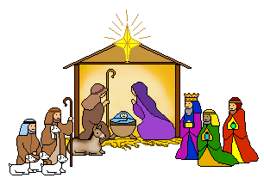

**We wish you**

**a blessed**

**Christmas.**